# Experiment No.: 07 Flow Totalizer

|  |  |
| --- | --- |
| **Academic Year** | **: 2021-22 Sem : I** |
| **Class** | **: TY BTech Instrumentation & Control** |
| **Course Name** | **: Process Instrumentation** |
| **Course Code** | **: IC3231** |
| **Name** | **: Shaunak Deshpande** |
| **Division** | **: IC-C** |
| **Roll No.** | **: 39** |
| **G.R. No.** | **: 11911180** |

**Experiment No.: 08**

**Flow Totalizer**

**Aim :** To study and calibrate the flow totalizer.

**Apparatus :** Flow totalizer, Current source, Digital multimeter, connecting wires etc.

**Theory :** Flow Totalizer is used to find the total amount of flow that has flown across the flow transducer. It is widely used in batch processes. The total volume of liquid passed across flow transducer is product of flow and time.

**Calibration :** Calibration of Flow Totalizer :

1. Input Current 4 -20 mA (Page-6)
2. Flow range calibration (Page-5)
3. Totalizer settings about engineering units (Page-5)
4. Totalizer settings about alarms (Page-4)

### Specifications of Flow Totalizer :

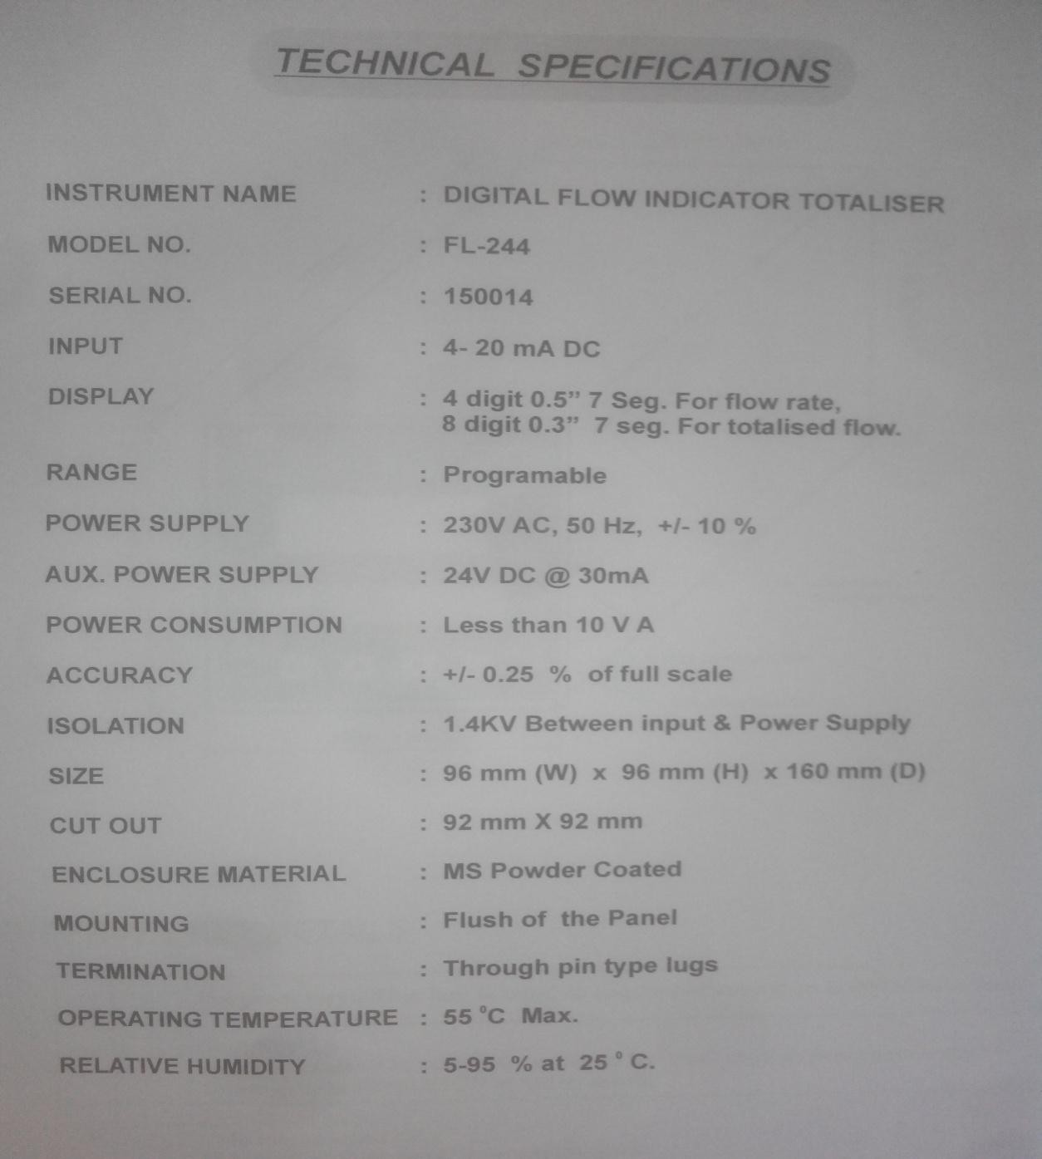

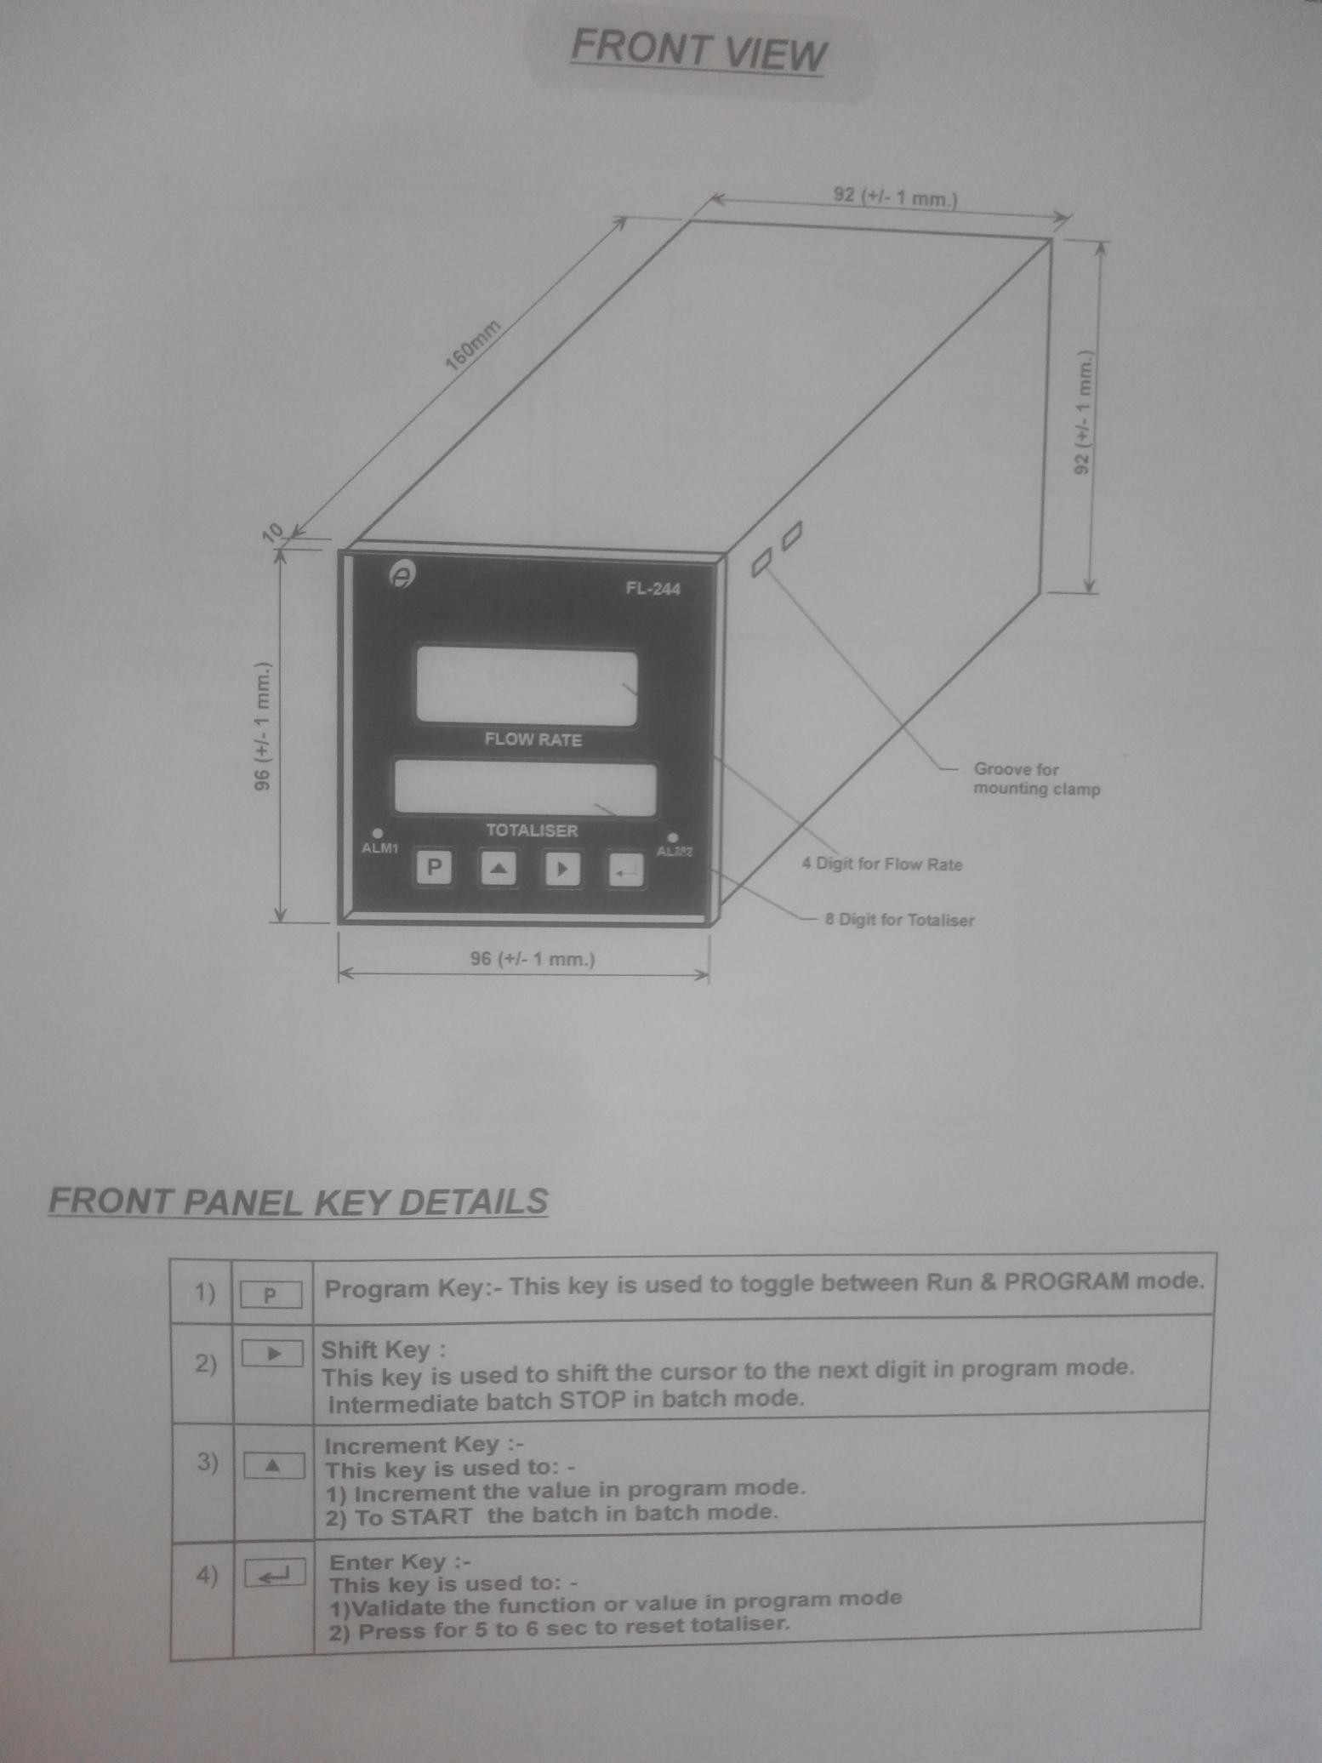

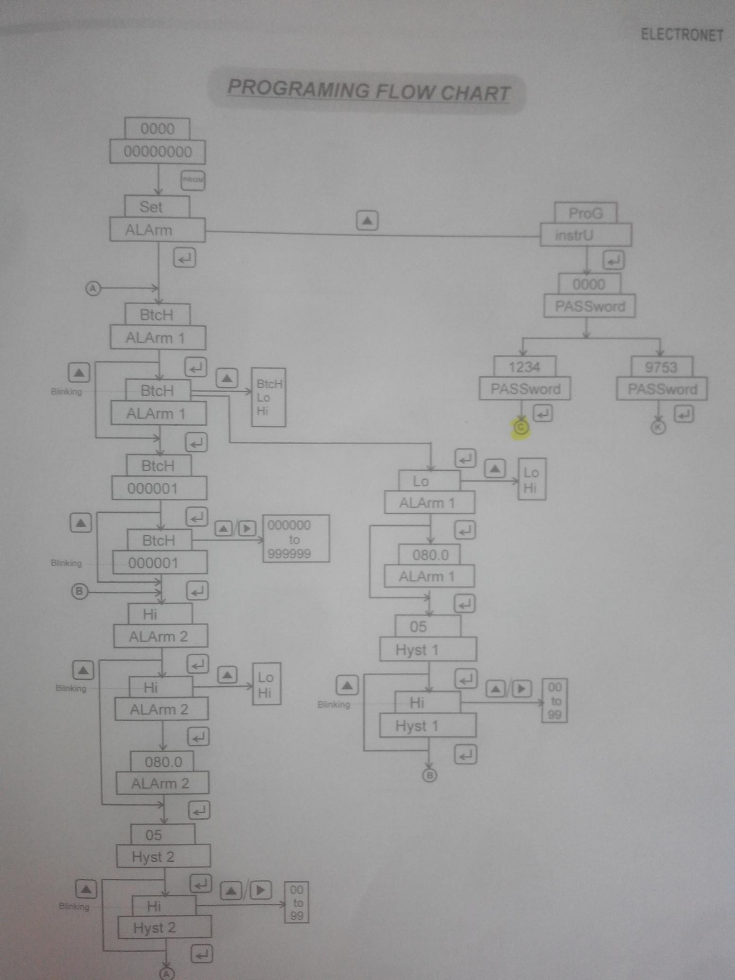

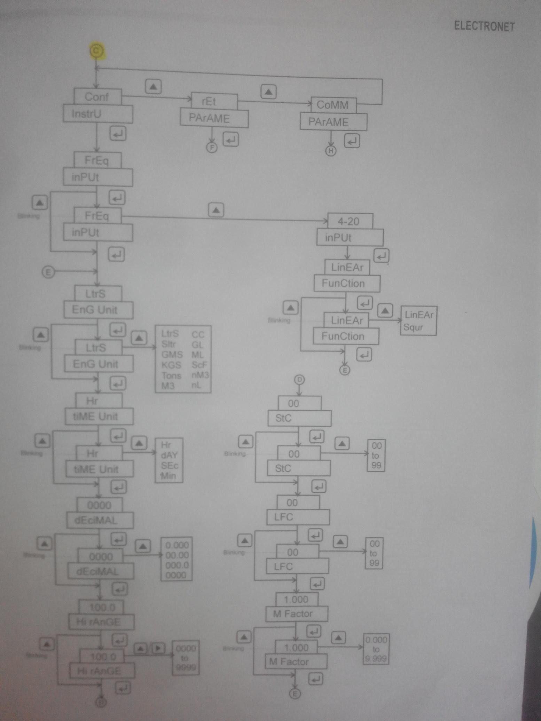

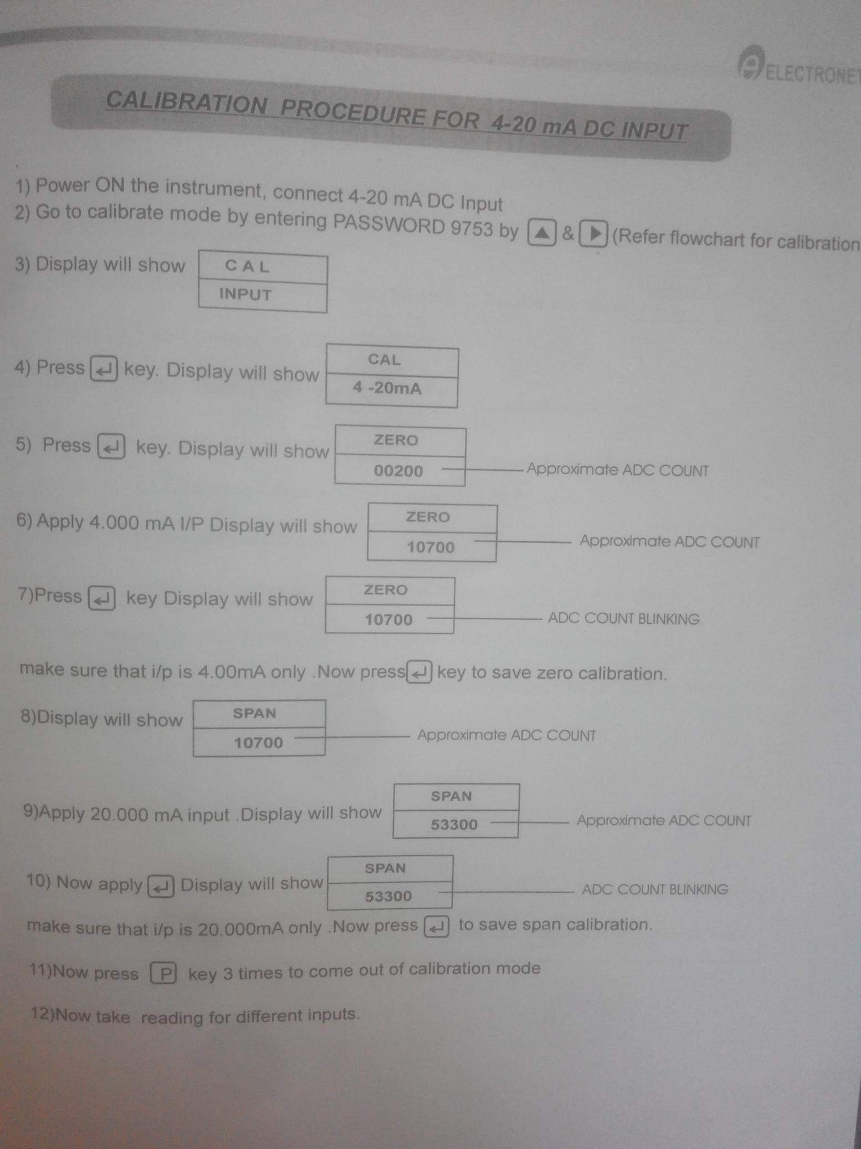

**Procedure:**

* 1. Connect the current source and flow totalizer as shown in the diagram.
  2. Switch on the power supply.
  3. Calibrate the flow totalizer for 4 to 20 mA DC current input.
  4. Calibrate the flow totalizer for minimum and maximum flow values. Also configure it for require engineering unit of flow and time.
  5. Vary the current in terms of percentage on the calibrated scale such as 0, 25, 50, 75 etc. notes down the corresponding flow and flow totalizer readings. Take five readings up to 100 on the calibrated scale.
  6. Plot the graph Flow Vs Current for the readings.
  7. Calculate the % error.

### Observations:

|  |  |  |  |  |  |  |
| --- | --- | --- | --- | --- | --- | --- |
| **Sr.**  **No.** | **Input Current mA** | **Flow** | | **Total Flow for 1 min.** | | **% Accuracy** |
| **Expected Flow LPM** | **Actual Flow LPM** | **Expected Total flow Ltr** | **Actual Total Flow Ltr** |
| 1. | 4 | 0 | 0.06 | 0 | 0.43 | 0.64 |
| 2. | 8 | 25 | 25 | 25 | 25.54 | 0 |
| 3. | 12 | 50 | 50 | 50 | 57.62 | 0 |
| 4. | 16 | 75 | 74.86 | 75 | 78.23 | 0.14 |
| 5. | 20 | 100 | 99.9 | 100 | 101.15 | 0.1 |

**Sample Calculation:**

% Error = [(Required flow – Actual flow) / Span ]*100

### Conclusion: -

### We studied the flow totalizer and calibration procedure for flow totalizer.

### We calculated the actual flow in LPM and total flow in LPM for different current values.

### We studied specifications of flow totalizer.

### We studied calibrated the flow totalizer as per the procedure given in the flow totalizer user manual.

## Scale: -

## On X-axis: 1 cm = 2 mA On Y-axis: 1 cm = 10 Ltr

Screenshots: -

1. Circuit diagram of flow totalizer

1. Arduino code: -

1. Output: -

1. Observation Table: -

